The vocabulary vision for North

- Rationale for teaching vocabulary
- How we acquire language
- Language rich environment
- Academic language
- Strategies for teaching vocabulary
- Assessing Vocabulary

Why teach vocabulary?
Vocabulary is the knowledge of words and word meanings. As Steven Stahl (2005) puts it, "Vocabulary knowledge is knowledge; the knowledge of a word not only implies a definition, but also implies how that word fits into the world." Vocabulary knowledge is not something that can ever be fully mastered; it is something that expands and deepens over the course of a lifetime. Instruction in vocabulary involves far more than looking up words in a dictionary and using the words in a sentence. Vocabulary is acquired incidentally through indirect exposure to words and intentionally through direct instruction in specific words and word-learning strategies.

Studies have shown that reading comprehension and vocabulary knowledge are strongly correlated and researchers have found that word knowledge in primary school can predict how well students will be able to comprehend texts they read in high school.

Limited vocabulary prevent students from comprehending a text. Poor readers often read less, because reading is difficult and frustrating for them. This means they don’t read enough to improve their vocabulary, which could, in turn, help them comprehend more. This perpetuating cycle can mean that as students continue through middle school and high school, the gap between good and poor readers grows wider. Direct instruction in vocabulary can help arrest this cycle. Good readers often acquire much of their vocabulary through wide independent reading, also known as incidental learning. However, explicit instruction can help students learn enough words to become better readers (and thus acquire even more words). Direct vocabulary instruction is useful for students at all ability levels, but it is particularly useful for beginning students who have a limited reading vocabulary and little exposure to incidental vocabulary learning outside of school. The average student learns about 3,000 words a year, or six to eight words per day—a remarkable achievement! If students are taught new words at a rate of eight to ten words per week for 37 to 50 weeks, about 300 to 500 words per year can be taught through direct instruction.

This leaves a large portion of words to be learned through independent reading, which is essential to acquiring word knowledge. Although the percentage of words learned through direct instruction may seem small, it is significant. Steven A. Stahl has pointed out that for students at the lower end of the vocabulary range, who learn perhaps 1,000words a year, a gain of 300 words equals a 30 percent increase, and that for average students a gain of even 10 percent is educationally significant—especially if it is repeated year after year.

Experts agree that a combination of direct instruction of word meanings, discussions about words and word parts, and encouragement of wide reading is the best way to help students develop vocabulary.

Alex Quigley in his book ‘Closing the Vocabulary Gap’ states:
- ‘Put simply, the word rich get richer, but the word poor get poorer.’
- ‘With a bigger, harder curriculum, in any subject, we must begin with the words.’

The Ten big reasons to teach vocabulary:
    - Vocabulary knowledge is highly correlated with reading comprehension and reading achievement.
    - Vocabulary knowledge helps students retain what they read.
    - Students need to know 90-95% of the words to even learn new ones in context.
    - Vocabulary acquisition is essential to help minimize the vocabulary knowledge gap which widens over time if words are not learned.
    - Vocabulary knowledge is correlated with occupational success.
    - Vocabulary knowledge helps students with language comprehension.
    - Vocabulary helps students express themselves more precisely and sharpens communication skills.
    - Vocabulary knowledge helps students with written and spoken language production.
    - Vocabulary is required for students to achieve cognitive academic language proficiency.
10. Vocabulary knowledge enhances our ability to function in a complex world.

How we acquire language

Vocabulary can be defined as the words we must know to communicate effectively and consists of four related vocabularies.
- Listening (receptive) vocabulary-words we hear and understand.
- Speaking (expressive) vocabulary-words we use when we talk.
-Reading vocabulary – (receptive) words we understand when we read.
-Writing vocabulary (expressive)-words we use to convey meaning in our writing.
-“Vocabulary is the glue that holds stories, ideas and content together…..making comprehension accessible for children.”(Rupley, Logan and Nichols)

What does it mean to ‘know’ a word
Recognition – awareness of new word in speech or reading
Generalisation – ability to define a word
Application – be able to use the word in different contexts
Breadth – knowledge of multiple context related meanings
Precision – ability to apply term correctly in a situation and recognise inappropriate use
Availability – recall of the word in thinking and spoken or written discourse

Language acquisition
We strive for all of our learners to have a rich and varied vocabulary. We know that pupils who enter school with a strong speaking and listening vocabulary -high performing five year olds - will have an oral vocabulary of about 14,000 words which is almost twice as much as low performing pupils and that gap gets wider each year. We aim to narrow this gap significantly while at North Primary.
‘After the age of seven, the majority of new words we learn come from reading. Encourage children to read as much and as widely as possible.’
James Clements – director of Shakespeare and More.
A pupil who reads 20 minutes per day outside of school reads almost two million words a year. A pupil who reads less than a minute per day outside of school reads only around 8,000 to 21,000 a year.
Texas Reading Initiative 2002
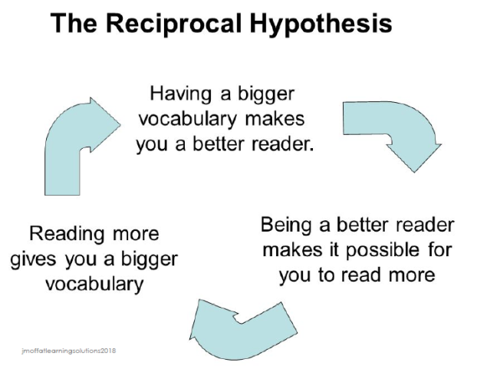
At North we utilise every aspect of the teaching and learning cycle in order to build vocabulary and teach language acquisition skills. We recognise the reciprocal hypothesis for reading and vocabulary building, and aim to use all the ways in which we teach reading to ensure progress in language acquisition through indirect instruction.
Indirect Instruction | Direct Instruction
-Daily Conversation  -Independent Reading  -Reading –Aloud to pupils  -Oral discussions  -culture of reading for pleasure | -Formal/Vocabulary curriculum  -Teaching specific words  -Word Analysis  -Multiple exposure to words in meaningful contexts

While we promote language acquisition through reading, we also teach Vocabulary through direct instruction. We encourage language acquisition through exploring the impact of language, vocabulary development in the PoR session and the wider curriculum. In addition, we focus specifically on Language impact as a reading skill. Furthermore, we question and teach toward the content domain areas KS1 and KS2 (E.g. 1a -Draw on knowledge of vocabulary to understand texts; 2a - Give/explain the meaning of words in context) and the end of EYFS standards set out in development matters.

Our teachers select vocabulary for direct instruction by analysing texts, subject content and key knowledge and selecting words and phrases pupils will find unfamiliar, are crucial to understanding and are not likely to be learned independently through the use of context. We use the ‘tiered cake’ (see diagram below) approach and ask ourselves questions. E.g.
- How generally useful is the word? Is it a word the pupils will encounter in other texts? Will it be of use to them when describing their own experiences orally and in their writing?
- How does a word selected relate to other words and ideas pupils know or have been learning?
- Which words will only need brief attention? Which words are STAR words which will be the focus of the vocabulary instruction?

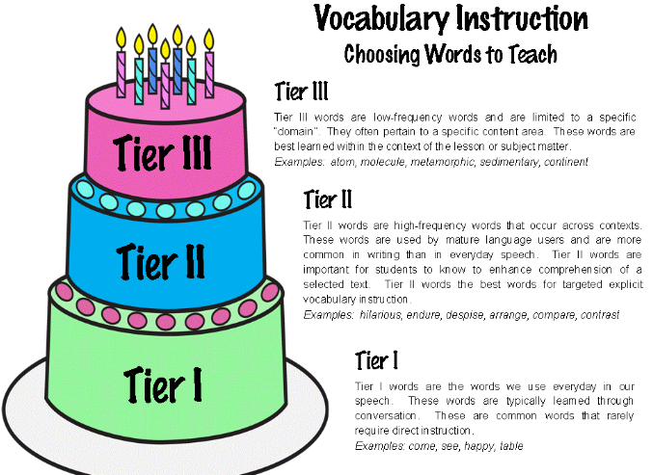

At North our model for the direct planned teaching of vocabulary includes the processes of:
1. Selecting a text/subject content which will expand the pupils’ vocabulary
2. Selecting the target words you want the pupils to explore from the chosen text/subject content.
3. Reading the text aloud.
4. Using student friendly explanations, visuals and definitions to explain the meaning of the target words.
5. Combining definitions with contextualised examples outside of the text.
6. Planning for frequent encounters with the target words on a regular basis over the week.
7. Ensuring there are planned opportunities to revisit and use target words in pupils’ writing.
All staff are trained and utilise the consistent cycle model of STAR to plan for our direct teaching of vocabulary.

STAR cycle
Select - the really useful vocabulary from the topic, subject content or class text
Teach - the selected vocabulary in a structured way
Activate - the meaning by using words in the context and linking the word to what the child already knows
Review - the taught words to help the child remember them

In addition we use a cycle of cultivation and harvesting of key vocabulary in our wider curriculum.
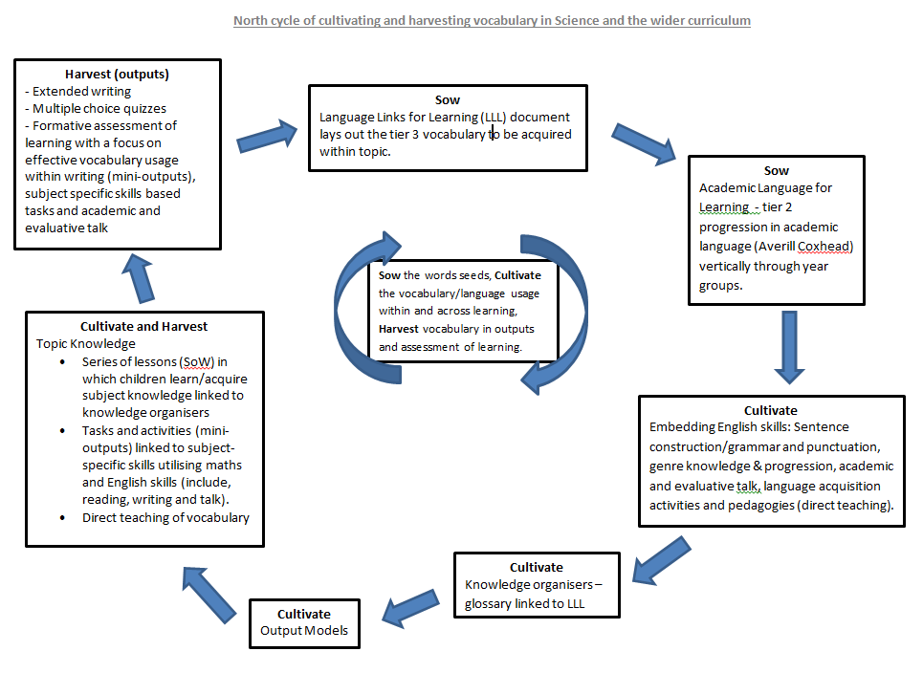

Vocabulary rich environments
We strive to make our learning environments word rich and make vocabulary learning an important area of the curriculum/classroom display. We have curriculum displays that show key vocabulary in learning across the curriculum. All key Vocabulary from our wider curriculum is contained in our knowledge organisers and STAR words are displayed on working walls and vocab charts for all subjects.
In addition, teachers discuss and use new vocabulary and set specific work on Language acquisition within the teaching and learning of grammar, punctuation and spelling, both explicitly in the teaching of spelling (e.g. prefixes and suffixes, root words, contextual reference) and in specific areas of the GAPS curriculum (e.g. Etymology). We also use a vocab wall for our Power of reading texts studied within our English curriculum.
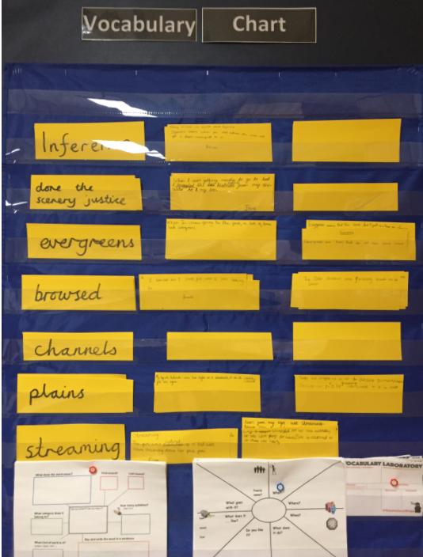

The North Vocabulary

At North we map out and teach a specific vocabulary meaning children acquire a range of tier 2 and 3 vocabulary as they learn. This is mapped out in subject specific vocabulary documents showing the progression in vocabulary from reception right through to year 6.

In English STAR words are taken from the PoR to ensure a deep understanding of the text being studied.

Word lists can be found here: https://drive.google.com/drive/folders/1OFqmOWZm5a9sxkwq0TfIkwUOaC05BL0y

Specific tier 2 academic language is taught from reception. This language has been selected using the most frequently used tier 2 words identified from Averill Coxheads research on the use of academic (tier 2) language. We have included this to ensure our children are well prepared for the academic demands of their education beyond North and have an ever-growing academic vocabulary with which to effectively communicate.
https://docs.google.com/spreadsheets/d/1geOsfK7LaoDMAUAPOlkGf6QjiaAodFVGMhArV-YjFpM/edit#gid=0
Specific Vocabulary is embedded in our knowledge organisers and Language links for learning documents which are shared with every child via google classroom
