Behaviour Policy

Changed: 20.4.22
Approved: 22.3.23 | Review Date:
Reviewed: Annually | Next Review Date:
Reviewed:

Aims
A good behaviour management policy is at the centre of teaching and learning and underpins responsible membership of the school community. As such it makes a significant impact to the school’s aims:

• To provide a challenging, stimulating, caring and safe environment where all children are encouraged to develop to their full potential
• To encourage independence, responsibility, self-discipline and pride in our achievements and our school
• To ensure all community members are cared for and respected including protected characteristics
• To develop every child academically, physically, morally, spiritually, socially and culturally to reach their full potential
• To ensure all children have access to inclusive and high quality teaching and resources
• To prepare our children for the future, nurture a desire to learn and become active and engaged citizens
• To show care and responsibility in the way we all behave with one another in our school and the surrounding community
• To enable parents and carers to take an active role in their child’s learning including social and moral development

North’s Expectations
We have a strong ethos of Imagine, Believe, Achieve.
Our ethos is displayed in every room of the school and is shared with children at the beginning of every year, during assemblies and during P.S.H.E. Children are praised for following the school’s expectations
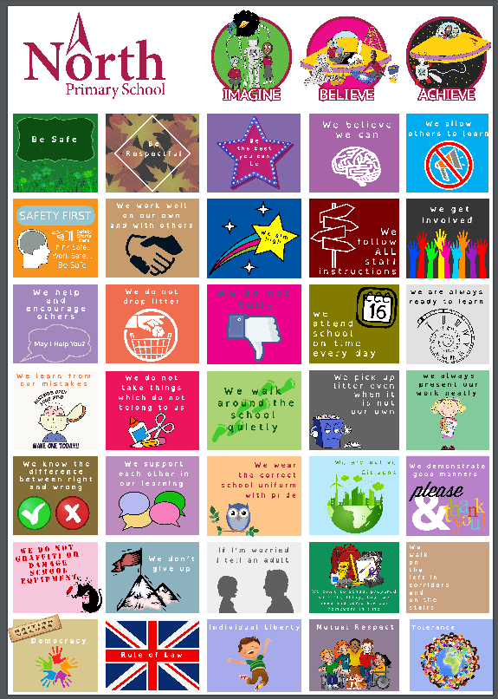

Golden Rules
Be Safe
Be Respectful
Be the best you can be

Principles
Positivity is at the heart of behaviour management and here are the approaches that
underpin this policy:
- Staff model the standards of courtesy expected from the children
- Children are explicitly taught the language of emotion during PSHE through the RULER method
- There should be consistent use of positive reinforcement ‘I am pleased to see….working quietly’.
- Every member of staff to praise in every lesson at least twice more than every reprimand, reprimands should be private rather than public.
- Staff are to manage children’s behaviour in a calm, assertive manner. Don’t point fingers or appear aggressive.
- Rewards and sanctions are to be applied in a fair and consistent way.
- For serious incidents an investigation needs to be completed as soon as possible.
- If children are sent to the headteacher they are given Reflection Sheets or Apology Templates to ensure they reflect on their actions

Behaviour pupils expect of the school staff team
Treat people equally
Encourage us
Keep our lessons interesting
Never be offensive
Let us sit where we like at lunchtime
Be helpful to children who don’t know the answer to the question
Let us talk to the children in KS1 at playtime

Rewards
- Verbal Praise for following guidelines, golden rules, effort and achievement
- Dojos - teachers regularly share dojo charts with children and termly whole school award ceremony takes place.
- Postcards issued for imagine, believe, achieve, our values. We also have postcards to reward British Values; democracy, Rule of Law, Individual Liberty, Mutual Respect and Tolerance, refer to the Equality Policy.

Recorded Behaviour
We record incidents of inappropriate behaviour on Arbor, in order to track pupils patterns of behaviour. Multiple incidents will trigger a response from the senior leadership team. The response could range from staff training to emotional support for the child or referral for additional support for the child and possibly a report card. It will involve contact with parents.

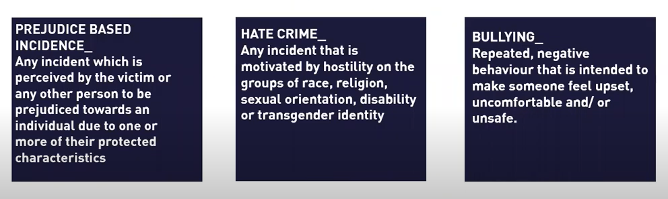
These incidents must be recorded in the Internal Exclusion section of Arbor due to their severity. The child must complete a reflection sheet, which should be uploaded to the incident. A report card might also be issued and this should also be uploaded to Arbor on completion .

Behaviour is recorded under these categories:
Not following instructions
Unkind
Unsafe
Disrespectful
Selfish
Unprepared
Lack of effort
Theft

Sanctions :

Incident | Suggested Sanctions
Not following instructions | Verbal Warning
Unkind | Lose 3 Dojos  More than once may need to be sent to the other class
Unsafe  Putting others or yourself at risk of harm | Text parents  Lose 5 minutes playtime
Selfish | After explanation around the need to share  Lose 3 minutes playtime
Disrespectful | Go to other class for 10 minutes
Lack of effort | 5 minutes of playtime spent making an effort
Unprepared | Text parents  Homework club

• Internal Exclusion –This sanction might be used for serious repeated offences or serious incidents.
Child takes work to another class for 1 day
The parent/carer is informed in writing. The sanction is recorded on Arbor.
A meeting is arranged between the parent/carer and the headteacher
An internal exclusion can only be issued by an SLT member.
Child must complete a reflection sheet which should be uploaded to CPoms see Appendix 1 and 2 .

- Lunchtime Exclusions children may need time out at lunchtime if their behaviour has been unsafe.

• Report Card– a child may be given a report card by SLT. The child is expected to report to the headteacher and have their card signed every day for 2 weeks. Parents would be informed and expected to be involved in improving behaviour, see appendix 3.

• External Exclusion – Either fixed-term or permanent. This is only considered
in situations of extreme behaviour, for example: physical attack of staff or
pupils, serious vandalism, stealing of school property, or persistent bullying
where the measures outlined in the Anti-Bullying Policy have been
unsuccessfully tried and the problem persists.

Children must be sent directly to the Headteacher or deputy in her absence. They
must be sent with work to do. On return the child would be on report and would
need to show their report card to the deputy headteacher every afternoon for two
weeks.

The Chair of Governors and Local authority are informed. The Governing Body will
review all permanent and certain fixed term exclusions. See the Exclusion of Pupils
Policy for further details.

A punishment must be proportionate. In determining whether a punishment is reasonable, section 91 of the Education and Inspections Act 2006 says the penalty must be reasonable in all circumstances and that account must be taken of the pupil’s age, any special educational needs or disability they may have, and any religious requirements affecting them.
The school will consider whether the behaviour under review gives cause to suspect that a child is suffering, or is likely to suffer, significant harm. Where this may be the case, school staff will follow the school’s safeguarding policy. They will also consider whether continuing disruptive behaviour might be the result of unmet educational or other needs. At this point the school will consider whether a multi-agency assessment is necessary.

- Pupils with SEND or special circumstances may have agreed altered sanctions.These will be personalised to acknowledge their current level of need

Recording Incidents
All internal and external exclusions are recorded on Arbor to provide an ongoing record
of a child’s behaviour.

Communication
Parents and carers will be informed of positive behaviours through certificates, letters and postcards home. All initial communication about behaviour takes place between the class teacher and the parents/Carers. If behaviour is unacceptable i.e lunchtime exclusion parents/carers will be contacted
and invited to meet with the SLT/class teacher. Serious behaviour issues i.e. those that lead to internal exclusion will lead to the parents being invited to meet with the Deputy/Headteacher. Very serious behaviour issues which lead to external exclusions will be dealt with regard to current Government Guidance.

Bullying
All reports of bullying made to staff are treated seriously, please see the Anti-Bullying Policy and Equalities Policy. Children will be expected to complete an equalities incident report and sign an anti-bullying contract. All significant incidences of bullying will be recorded and reported to the Governing Body.

E-Safety
All reports of cyberbullying are taken seriously. As per our e-safety policy, pupils are regularly reminded about the impact of cyber bullying. Where cyber bullying has occurred outside of school, parents are informed and pupils are interviewed and reminded of expectations.
Pupils and parents are offered support and advice via the Family Support Worker. Any pupil found to be using the ICT inappropriately, might be denied access to it.

Malicious Allegations towards staff
In any situation where a malicious allegation has been made towards a pupil or member of staff, whether on or off site, the school will take every measure deemed necessary to intervene and involve the relevant authorities.

School Uniform
It is also the responsibility of all staff to ensure that all children wear correct school uniform. Texts will be sent home to children who do not follow uniform guidelines.

Outside of school
The school expects a high standard of behaviour from pupils when in the community. The behaviour policy applies off site when travelling to and from school, or on school trips.

Home School Agreement
All parents are encouraged to sign a Home-School Agreement which covers issues such as homework, behaviour and e-safety.

Pastoral Lead and Play Therapist
When a child continuously displays inappropriate behaviour, or is consistently breaking the rules, they are referred to North’s Pastoral Lead and or Play Therapist.

The School welcomes our duties under the Equality Act 2010 to eliminate discrimination, advance equality of opportunity and foster good relations in relation to age (as appropriate), disability, ethnicity, gender (including issues of transgender, and of maternity and pregnancy), religion and belief, and sexual identity. We will take full account of our duties to those pupils with disabilities when considering the support provided for and sanctions issued to pupils.

Use of reasonable force

School staff have the legal power to use reasonable force on pupils. This is used either to control or restrain. It must be no more than is needed in the circumstances to prevent a child from hurting themselves or others, from damaging property or from causing disorder

Other
There are other policies that may be read with this document, notably the PositiveHandling Policy and Anti-Bullying Policy and E-Safety Policy.

Appendix 1 Reflection Sheet KS2
Appendix 2 Reflection Sheet KS1
Appendix 3 Report Card
Appendix 4 Ruler

Behaviour Reflection Sheet - KS2
Use mood words to help you to complete the reflection sheet
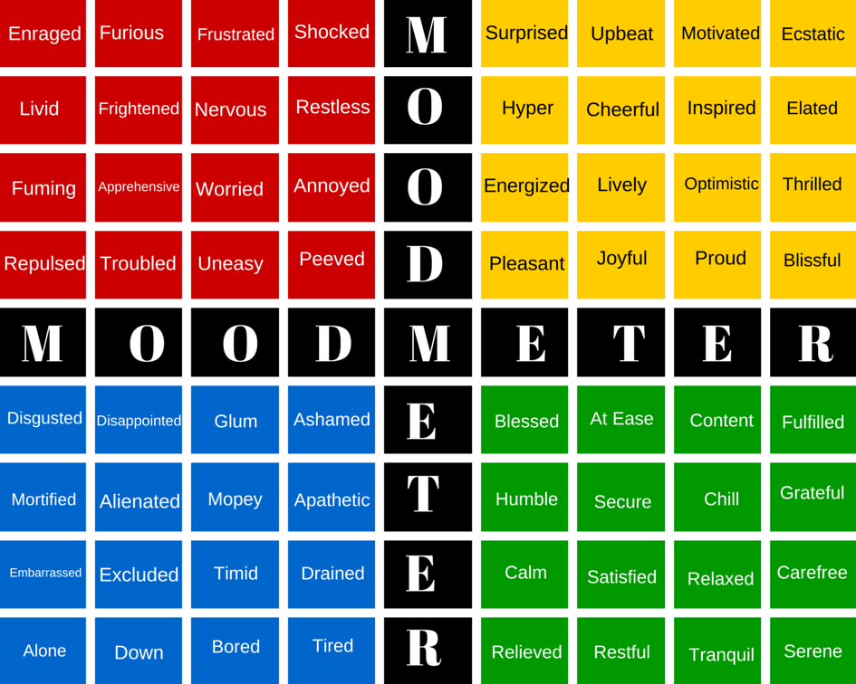
What Happened?
What did I do?
What did other people do?
How did I feel?
What could I have done differently?
What did I achieve?
What could have gone better?
What have I learnt?

Teacher - please upload this reflection to the child’s CPOMs

Behaviour Reflection Sheet - KS1

What Happened?

How did you feel?

How would you like to feel?

What should you do?

Behaviour Report Card
Name: Class:
Teacher, please select a word to describe the child’s behaviour/mood during each session

Week 1 | Monday | Tuesday | Wednesday | Thursday | Friday
9-10.30
Playtime
10.45-12.15
Lunch
1.15-2.15
2.15-3.15

Week 2 | Monday | Tuesday | Wednesday | Thursday | Friday
9-10.30
Playtime
10.45-12.15
Lunch
1.15-2.15
2.15-3.15

More information relating to the RULER approach: https://www.rulerapproach.org/

