Behaviour Reflection Sheet - KS2
Use mood words to help you to complete the reflection sheet
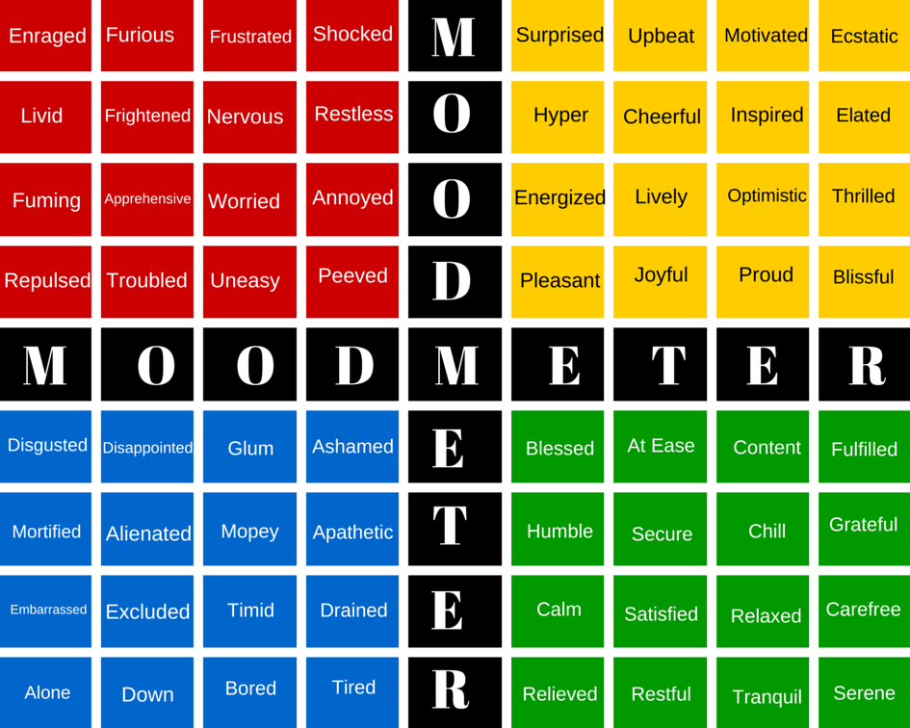
What Happened?
What did I do?
What did other people do?
How did I feel?
What could I have done differently?
What did I achieve?
What could have gone better?
What have I learnt?

Teacher - please upload this reflection to the child’s CPOMs

