Anti Bullying Policy

Changed: 4.22
Approved: | Review Date:
Reviewed: Annually | Next Review Date:
Reviewed:
This policy is based on DfE guidance “Preventing and Tackling Bullying” July 2017 and supporting documents. It also takes into account the DfE statutory guidance “Keeping Children Safe in Education” 2016. The school has read Childnet’s “Cyberbullying: Understand, Prevent and Respond: Guidance for Schools” and The Diana Award.
1. Together we will stop bullying (our school commitment)
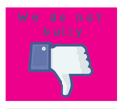
2. Ethos and values of our school community
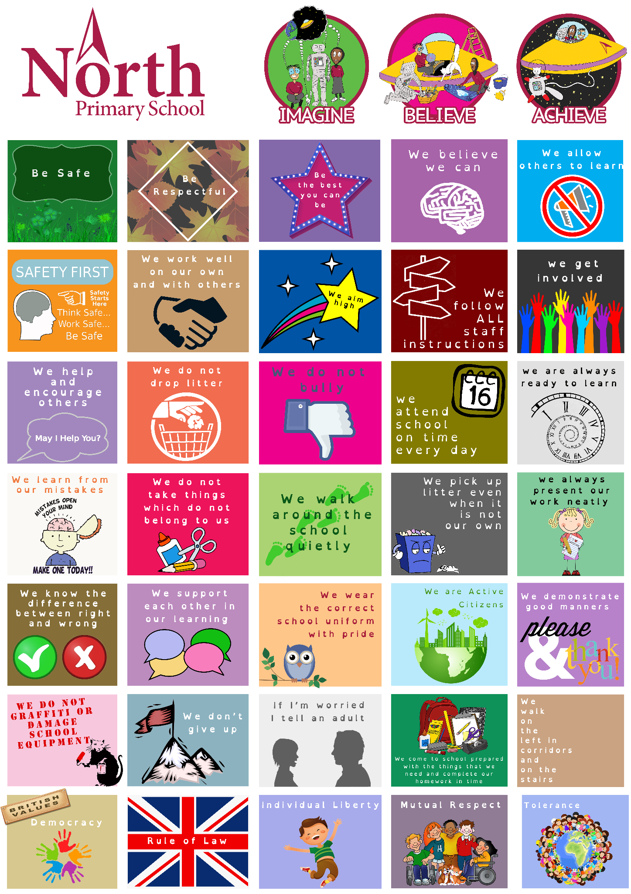

3. Our definition of bullying
‘Repeated negative behaviour that is intended to make others feel upset, uncomfortable or unsafe.’

4. Understanding bullying behaviour
There are three types of bullying behaviour: verbal, indirect and physical.
Verbal: The repeated negative use of speech, sign language or verbal gestures to intentionally hurt others. Examples: Swearing, Discriminatory Language, Offensive Language (concerning personal choices), Hurtful Comments.
Indirect: the repeated negative use of actions, which are neither physical or verbal to intentionally hurt others. Examples: Cyber Bullying, Rumours, Isolating Someone, Damaging/Taking Property, Secret Sharing, Physical Intimidation
Physical: The repeated use of body contact to intentionally hurt others. Example: Pinching, Kicking, Punching, Slapping, Tripping.

5. Bullying and keeping children safe (including how the anti-bullying policy relates to your safeguarding policy and any other related documents)
Bullying can be a form of peer on peer abuse and can be emotionally abusive; it can cause severe and adverse effects on children’s emotional development. Link to peer on peer abuse section of safeguarding policy
6. Bullying and discrimination
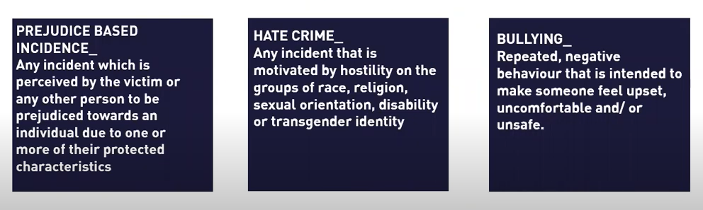The sanction for discrimintaion is Internal Exclusion. These incidents must be recorded in the Internal Exclusion section of Arbor due to their severity. The child must complete a reflection sheet, which should be uploaded to the incident. A report card might also be issued and this should also be uploaded to Arbor on completion - see Behaviour 4.2022 Appendix 1-3.
7. Stopping bullying wherever it takes place.
Bullying can have a long lasting impact on a young person’s mental health for those who are getting bullied, witnessing bullying and doing the bullying. That is why our first step is about securing and ensuring the safety and wellbeing of those involved. Below are some questions that should be asked at this stage. It is important to have a record of these considerations. In most bullying situations you do not need to use outside agencies such as social workers or police however this should always be considered. Young people often tell us that at this stage they aren’t asked what they would like to happen. So it’s important to involve them along the way.
Are all pupils involved safe?
Is anyone’s physical health or wellbeing at risk?
Have you needed to use the child protection policy?
Did you access any outside support? E.g. NHS, police.
Have you recorded the incidents themselves (see Appendix A)?
Did you tell the pupil/s being bullied that you are taking it seriously, it’s not their fault and they don’t have to put up with bullying?
Have you asked the pupil/s being bullied how they’re feeling and how they think it can be resolved?
Have you informed the pupil/s being bullied what you will do next?
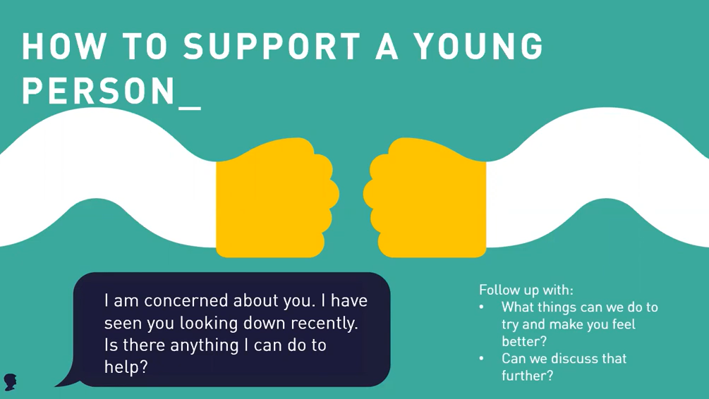
8. Preventing bullying
PSHE curriculum has specific lessons on how to respond to difficult situations. Children can access ‘Listening Post’ for a conversation with a staff member (usually Denva - Play therapist). Children are explicitly taught the language of emotion so that they can articulate their feelings through RULER.
We celebrate odd socks day in November, to highlight the negative effects of bullying and how children should report any negative behaviour.
Staff have completed this online training:
https://anti-bullyingalliance.org.uk/tools-information/free-cpd-online-training
(e.g., spotting the signs and symptoms of bullying, guidance on physical contact and consensual touch, zero tolerance for abusive or offensive language, curriculum content, staff training, pupil and parent workshops, participation in Anti-Bullying Week and Friendship Friday)
9. Reporting bullying
All incidents of negative behaviour are reported on Arbor. All staff look for patterns of repeated intentional negative behaviour in the behaviour records and will follow up with further investigation if a pattern occurs. Any allegation of bullying (repeated negative intentional behaviour) will be recorded on victim’s CPOMS and an investigation report completed.
Incidents of bullying behaviour should be recorded on the Arbor Internal Exclusion tab for the perpetrator. They should complete a reflection sheet and should be on report for two weeks. Both documents should be uploaded to the Internal Exclusion incident. The parent of the Internally Excluded child should be invited for a meeting with a member of SLT.
Any child who has been the victim of bullying should be referred to Denva, Play therapist. It may be that the perpetrator is also referred for emotional support, depending on the case.
10. Responding to bullying
https://anti-bullyingalliance.org.uk/sites/default/files/uploads/attachments/ABA_Responding_To_Bullying_Incidents_School_Tool.pdf
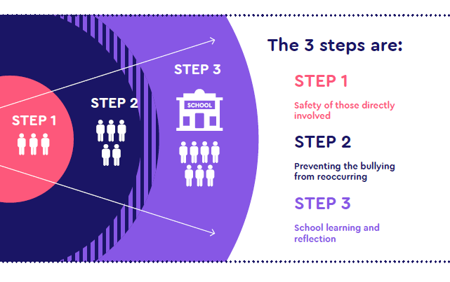
11. Measuring progress
The school will ensure that they regularly monitor and evaluate mechanisms to ensure that the policy is being consistently applied.
Any issues identified will be incorporated into the school’s action planning.
The headteacher will be informed of bullying concerns, as appropriate.
The named Governor for Safeguarding will report on a regular basis to the governing body on incidents of bullying, including outcomes.

12. Communicating the policy
Child Policy
Parent Policy
Website support
13. Links to legislation
There are a number of pieces of legislation which set out measures and actions for schools in response to bullying, as well as criminal and civil law. These may include (but are not limited to):
o The Education and Inspection Act 2006, 2011
o The Equality Act 2010
o The Children Act 1989
o The Education (Independent School Standards) Regulations 2014 ( if appropriate)
o Protection from Harassment Act 1997

Supporting adults
Our school takes measures to prevent and tackle bullying among pupils; however, it is equally important to recognise that bullying of staff and parents, whether by pupils, parents or other staff members, is unacceptable.
Adults (staff and parents) who have been bullied or affected will be supported by:
o Offering an immediate opportunity to discuss the concern with the designated safeguarding lead, a senior member of staff and/or the headteacher.
o Advising them to keep a record of the bullying as evidence and discuss how to respond to concerns and build resilience, as appropriate.
o Where the bullying takes place off school site or outside of normal school hours (including online), the school will still investigate the concern and ensure that appropriate action is taken in accordance with the schools behaviour and discipline policy.
o Reporting offensive or upsetting content and/or accounts to the service provider, where the bullying has occurred online.
o Reassuring and offering appropriate support.
o Working with the wider community and local/national organisations to provide further or specialist advice and guidance.
Adults (staff and parents) who have perpetrated the bullying will be helped by:
o Discussing what happened with a senior member of staff and/or the headteacher to establish the concern.
o Establishing whether a legitimate grievance or concern has been raised and signposting to the school’s official complaints procedures.
o If online, requesting that content be removed.
o Instigating disciplinary, civil or legal action as appropriate or required.
Note: Specific guidance is available for school leaders regarding dealing with complaints made on social networking sites by parents/carers: www.kelsi.org.uk/child-protection-and-safeguarding/e- safety

Education and Training
The school community will:
o Train all staff, including: teaching staff, support staff (e.g. administration staff, lunchtime support staff and site support staff) and pastoral staff, to identify all forms of bullying and take appropriate action, following the school’s policy and procedures (including recording and reporting incidents).
o Consider a range of opportunities and approaches for addressing bullying throughout the curriculum and other activities, such as: through displays, assemblies, peer support, the school/student council, etc.
o Provide systematic opportunities to develop pupils’ social and emotional skills, including building their resilience and self-esteem.
10) Involvement of pupils
We will:
o Involve pupils in policy writing and decision making, to ensure that they understand the school’s approach and are clear about the part they have to play to prevent bullying.
o Regularly canvas children and young people’s views on the extent and nature of bullying.
o Ensure that all pupils know how to express worries and anxieties about bullying.
o Ensure that all pupils are aware of the range of sanctions which may be applied against those engaging in bullying.
o Involve pupils in anti-bullying campaigns in schools and embedded messages in the wider school curriculum.
o Publicise the details of internal support, as well as external helplines and websites.
o Offer support to pupils who have been bullied and to those who are bullying in order to address the problems they have.
11) Involvement and liaison with parents and carers
We will:
o Take steps to involve parents and carers in developing policies and procedures, to ensure they are aware that the school does not tolerate any form of bullying.
o Make sure that key information about bullying (including policies and named points of contact) is available to parents/carers in a variety of formats.
o Ensure all parents/carers know who to contact if they are worried about bullying and where to access independent advice.
o Work with all parents/carers and the local community to address issues beyond the school gates that give rise to bullying.
o Ensure that parents work with the school to role model positive behaviour for pupils, both on and offline.
o Ensure all parents/carers know about our complaints procedure and how to use it effectively, to raise concerns in an appropriate manner.
12) Monitoring and review: putting policy into practice
13) Useful links and supporting organisations
Anti-Bullying Alliance: www.anti-bullyingalliance.org.uk
Childline: www.childline.org.uk
Family Lives: www.familylives.org.uk
Kidscape: www.kidscape.org.uk
MindEd: www.minded.org.uk
NSPCC: www.nspcc.org.uk
The BIG Award: www.bullyinginterventiongroup.co.uk/index.php
PSHE Association: www.pshe-association.org.uk
Restorative Justice Council: www.restorativejustice.org.uk
The Diana Award: www.diana-award.org.uk
Victim Support: www.victimsupport.org.uk
Young Minds: www.youngminds.org.uk
Young Carers: www.youngcarers.net
The Restorative Justice Council: www.restorativejustice.org.uk/restorative-practice-schools
SEND
Changing Faces: www.changingfaces.org.uk
Mencap: www.mencap.org.uk
Anti-Bullying Alliance Cyberbullying and children and young people with SEN and disabilities: www.cafamily.org.uk/media/750755/cyberbullying_and_send_-_module_final.pdf
DfE: SEND code of practice: www.gov.uk/government/publications/send-code-of-practice-0-to-25
Cyberbullying
Childnet International: www.childnet.com
Digizen: www.digizen.org
Internet Watch Foundation: www.iwf.org.uk
Think U Know: www.thinkuknow.co.uk
UK Safer Internet Centre: www.saferinternet.org.uk
The UK Council for Child Internet Safety (UKCCIS) www.gov.uk/government/groups/uk-council-for- child-internet-safety-ukccis
Race, religion and nationality
Anne Frank Trust: www.annefrank.org.uk
Kick it Out: www.kickitout.org
Report it: www.report-it.org.uk
Stop Hate: www.stophateuk.org
Tell Mama:www.tellmamauk.org
Educate against Hate: www.educateagainsthate.com/
Show Racism the Red Card: www.srtrc.org/educational
LGBT
Barnardos LGBT Hub: www.barnardos.org.uk/what_we_do/our_work/lgbtq.htm
Metro Charity: www.metrocentreonline.org
EACH: www.eachaction.org.uk
Proud Trust: www.theproudtrust.org
Schools Out: www.schools-out.org.uk
Stonewall: www.stonewall.org.uk
Sexual harassment and sexual bullying
Ending Violence Against Women and Girls (EVAW) www.endviolenceagainstwomen.org.uk
A Guide for Schools: www.endviolenceagainstwomen.org.uk/data/files/resources/71/EVAW- Coalition-Schools-Guide.pdf
Disrespect No Body: www.gov.uk/government/publications/disrespect-nobody-campaign-posters
Anti-bullying Alliance: advice for school staff and professionals about developing effective anti- bullying practice in relation to sexual bullying: www.anti-bullyingalliance.org.uk/tools- information/all-about-bullying/sexual-and-gender-related
Note: Additional links can be found in ‘Preventing and Tackling Bullying’ (July 2017) www.gov.uk/government/publications/preventing-and-tackling-bullying

