Relationships and Health Education
Policy 2020
Approved by: C Richards |  | Date: 12/02/2021
Last reviewed on: 12/02/2021
Next review due by:
Last modified on:
Table of Contents

1. Rationale 2
- Definition 2
- Relationships Education and Ofsted 2
- Moral and Values Framework 2
2. Statutory Requirements 3
3. Policy Development 4
4. Aims and Objectives 4
5. Equal Opportunities 6
6. Delivery of RHE: Content, Delivery and Training 7
7. Child Protection 9
8. Partnership with Parents 9
- Right to Withdraw 10
9. Roles and Responsibilites 10
- The Governing Body 10
- The Headteacher 10
- Staff 10
- Pupils 11
10. Signatures 11

1. Rationale

Definition:
The following policy refers to Relationships Education at North Primary School.
We define Relationships Education as learning about caring friendships, families and people who care for me, respectful relationships, online relationships, being safe, growing up and puberty. Sex Education is also covered in Relationships Education as well as aspects of sex education being covered in the National Science Curriculum (see appendix 1). Sex education is defined in this policy as preparing children for the changes that adolescence brings and the scientific process of how a baby is conceived and born.
Relationships Education provides an excellent forum to provide pupils with life-skills that will enable them to make informed decisions and protect themselves against harmful and exploitative situations. Relationships Education is therefore a tool to safeguard children.
Relationships Education contributes to the foundation of PSHE and Spiritual, Moral, Social and Cultural (SMSC) development and offers a valuable vehicle for promoting equality between individuals and groups. It involves an exploration of human and social diversity, and a fostering of self-worth whilst recognising, accepting and respecting differences.
Aspects of Relationships Education are taught as an integral part of the school’s PSHE provision throughout the primary school from Reception to Year 6. In this way, children are able to develop their ideas, knowledge and skills gradually and appropriately in a non-threatening environment.

Relationships Education and Ofsted:
The 2019 Ofsted framework states that pupils should be able to recognise online and offline risks to their well-being – for example, risks from criminal and sexual exploitation, domestic abuse, female genital mutilation, forced marriage, substance misuse, gang activity, radicalisation and extremism – and making them aware of the support available to them. It also states that schools should ensure they are developing pupils’ age-appropriate understanding of healthy relationships through appropriate relationship and sex education.
The 2019 Ofsted framework also states:
‘From September 2019, schools are able to follow a new relationships and sex education and health education curriculum. From September 2020, they will be required by law to follow it. Primary-age children must be taught about positive relationships and respect for others, and how these are linked to promoting good mental health and well-being. In addition, sex education will become mandatory at secondary level. If a school is failing to meet its obligations, inspectors will consider this when reaching the personal development judgement.

Moral and Values Framework:
The Relationships Education Policy will be sensitive towards the established morals and values framework of all the major world religions and philosophies. In its implementation, it will draw from the practical experiences of those who represent the various religious and philosophical groups within the local community. The Relationships Education Policy will be complementary with the Religious Education Policy of our school.

2. Statutory requirements
Schools are required to comply with relevant requirements of the Equality Act 2010. Further guidance is available for schools in The Equality Act 2010 and school’s advice. The DfE guidance states that schools should pay particular attention to the Public sector equality duty (PSED)
Under the provisions of the Equality Act, schools must not unlawfully discriminate against pupils because of their age, sex, race, disability, religion or belief, gender identity, pregnancy or maternity, marriage or civil partnership, or sexual orientation (collectively known as the protected characteristics). Schools must also make reasonable adjustments to alleviate disadvantage and be mindful of the SEND Code of Practice when planning for these subjects.
As a maintained primary school, we must provide Relationships Education to all pupils as per section 34 of the Children and Social work act 2017. We are not required to provide sex education, but we do need to teach the elements of sex education contained in the science curriculum. Our school also delivers sex education as part of Relationships Education. Parents can withdraw from sex education lessons (see section 8).
In teaching Relationships Education, we must have regard to guidance issued by the secretary of state as outlined in section 403 of the Education Act 1996.
At North Primary School we teach Relationships Education as set out in this policy.

3. Policy development

At North the review process followed recommended processes as laid out in the Ealing toolkit and the statutory guidance from the DfE. In the Autumn term of 2019, the PSHE lead (Michael Hall) attended two meetings with the Ealing Health Improvement Officer. The PSHE lead then developed and action plan Working within the advice given, best practice shared and statutory guidance, a working party was then set up with parents, staff and governors in order to review current policy and draft and implement a new policy to be implemented in September 2020. This policy has been developed in consultation with staff, pupils and parents. The steps taken to review the policy are as follows.
The Department for Education and Ofsted have clearly outlined aspects of Relationships Education that are statutory in all primary schools, therefore some recommendations or comments made during the consultation process may not be reflected in the final policy as our school has to ensure we are meeting statutory guidelines.

- Review – a member of school staff/members of the Relationships Education working party looked through the existing Relationships Education policy as well as local and national guidance for Relationships Education. The working party then reviewed the Relationships Education policy reflecting any advice and changes at local and national level.
- Staff consultation – Staff were consulted via an online RHE staff survey. The results of this survey informed the policy development and also informed additional support needed to enhance the delivery of RHE.
- Parent consultation Parents were invited on to a RHE working party and gave feedback on the policy and consultation process. Parents were consulted via an online RHE parents survey. The results of this survey informed the policy development and also identified additional work that was needed with parents to raise their awareness and knowledge of RHE in North Primary school.
- Pupil consultation – We consulted with pupils via the 2019 Health Related Behaviour Survey. The results of this survey were then used to inform the policy and inform the delivery of RHE in our school. A pupil focus group was also held so that pupils could feed into the content of the policy.
- Governor consultation - Governors were consulted on this policy via a governor meeting. All governors were sent the draft policy in advance of the staff meeting and were then invited to comment on the policy and make suggestions/amendments.
- Ratification – once amendments were made, the policy was shared with governors and ratified.

4. Aim and objectives

The aim of this policy is to enable the effective planning, delivery and assessment of Relationships Education.

The aims of Relationships and Health Education at our school is to:

- Develop confidence in talking, listening and thinking about feelings and relationships;
- Teach pupils the correct vocabulary to describe themselves and their bodies;
- Be prepared for puberty and understand the basic changes that happen during puberty;
- Understand how to keep their bodies healthy and clean;
- Understand how to keep themselves and their bodies safe;
- Help pupils develop feeling of self-respect, confidence and empathy;
- Help pupils recognise and form healthy friendships;
- Provide a framework in which sensitive discussions can take place;
- Foster respect for the views of other people

At North we also believe that for children to understand and display our shared values and British Values Relationships and health education is vital. The delivery of our relationships and health education curriculum directly supports the values we hold in our school and work to instil in all of our children moving forward with their education and lives.
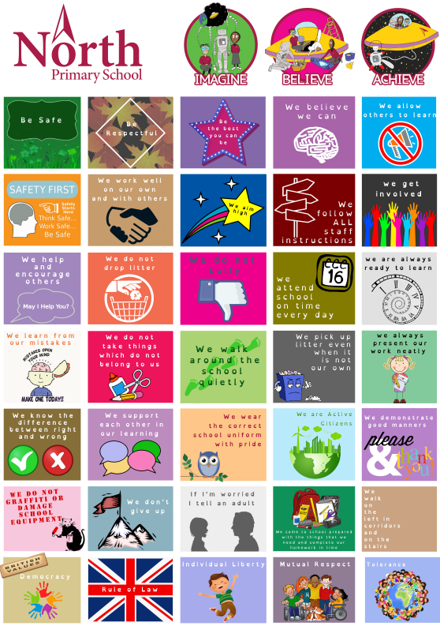
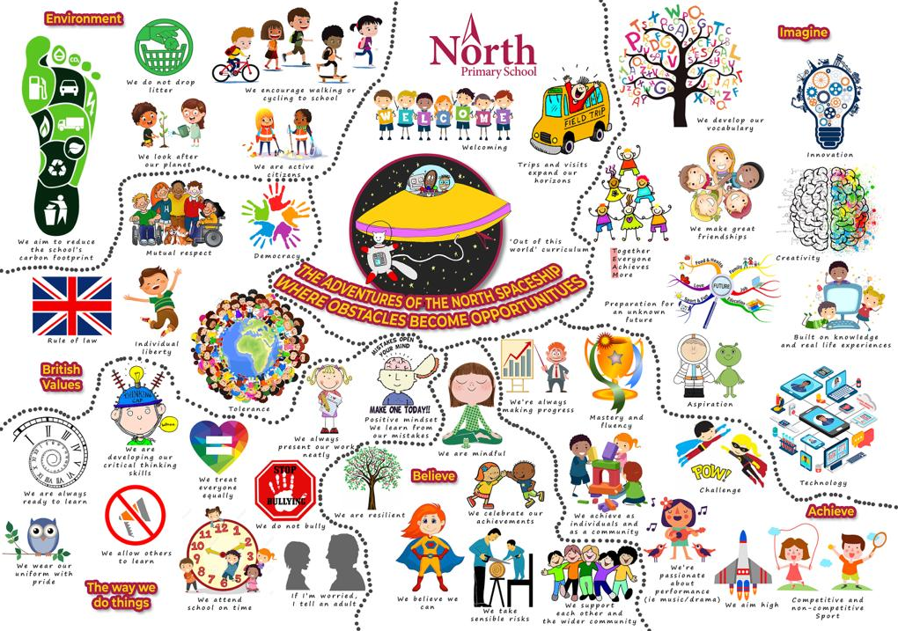

5. Equal Opportunities
North Primary School believes that Relationships Education should meet the needs of all pupils. Our school is committed to the provision of Relationships Education to all pupils and their differing needs. All staff are expected to give every pupil the chance to experience, participate and achieve the understanding of Relationships Education. Equal time and provision will be allocated for all groups but there may be occasions where children with special educational needs (SEN) are given extra support.
The planning and organising of teaching strategies will be consistently reviewed e.g. through lesson observations to ensure that no pupil is disadvantaged.

After consultation we have agreed on the on the following for North Primary School:
- Y5 and 6 lessons on the changing adolescent body will take place in gender specific groups. appropriate groups
- Appropriate methods of teaching to ensure needs of children with special educational needs, physical disabilities and learning difficulties are met. This will be done based on individual needs.

Provision for pupils who are looked after:
- The school works in close partnership with carers and other professionals e.g. social workers in regards to any looked after children on roll at North.
- Our family Welfare officer, Shahla Maqbool, supports any referral and request for support from outside agencies with regard to relationships and health education.

6. Delivery of RHE: Content, delivery and training

Relationships Education is taught within the personal, social, health and economic (PSHE) education curriculum. Our school uses the Ealing PSHE scheme of work to deliver PSHE and Relationships Education. Biological aspects of Relationships Education are taught within the science curriculum, and other aspects are also included in health education. A breakdown of what is covered in Science, Health Education and Relationships Education can be found in appendix 1. Please note that Sex Education is taught in Year 6 only.
The main aspects of Relationships Education are covered in the Summer Term as part of PSHE (See appendix 2) however many aspects of keeping safe, good and bad touch, healthy friendships, online safety, peer pressure, saying no, the PANTS rule (see website for more details https://www.nspcc.org.uk/preventing-abuse/keeping-children-safe/underwear-rule/), families and people who care for me are taught throughout the school year to ensure a consistent spiraling approach to keeping safe.

Relationships Education focuses on teaching the fundamental building blocks and characteristics of positive relationships including:
- Families and people who care for me
- Caring friendships
- Respectful relationships
- Online relationships
- Being safe
The above points are covered in an age appropriate way from EYFS to Year 6 (see appendix 2 for more detail). These areas of learning are taught within the context of family life taking care to ensure that there is no stigmatisation of children based on their home circumstances (families can include single parent families, LGBT parents, families headed by grandparents, adoptive parents, foster parents/carers amongst other structures) along with reflecting sensitively that some children may have a different structure of support around them (for example: looked after children or young carers).

The changing adolescent body (puberty) is covered in years 4, 5 and 6. It is covered at this age to ensure children are prepared for the emotional and physical changes that will happen during puberty. Puberty is part of the statutory Health Education curriculum (see appendix 1).

Sex education is covered in year 6 only. In these lessons we will focus on preparing children for the changes that adolescence brings and the scientific process of how a baby is conceived and born.

For more information about our Relationships Education curriculum, see appendix 2 and 3. Appendix 2 outlines the learning objectives for Relationships Education and appendix 3 outlines the vocabulary our school uses during these lessons.
As part of the PSHE curriculum our school delivered lessons on Female Genital Mutilation (FGM) to pupils from year 3 to year 6. These lessons are designed to raise pupil’s awareness of appropriate and inappropriate touch, including FGM. For more information on the content of these lessons, please speak to Mrs Maqbool.

Delivery:
Relationships Education will usually be delivered by a member of school staff, usually the child’s class teacher. If an external visitor is delivering all or aspects of Relationships Education, parents will be informed.
Relationships Education is usually delivered in mixed groups other than when it is deemed children be taught in appropriate groups.
Relationships Education will be assessed as part of the wider PSHE curriculum.
Staff are aware that views around RHE related issues are varied. However, while personal views are respected, all RHE issues are taught without bias. Topics are presented using a variety of views and beliefs so that pupils are able to form their own, informed opinions but also respect others that may have a different opinion.
Both formal and informal RHE questions arising from pupils are answered according to the age and maturity of the pupil(s) concerned. Questions do not have to be answered directly and can be addressed individually later. The school believes that individual teachers must use their skill and discretion in this area and refer to the Child Protection Lead if they are concerned.
The following are protocols teachers follow for discussion (‘Ground Rules’)
- No one (teacher or pupil) will have to answer a personal question
- No one will be forced to take part in a discussion
- Only correct/agreed names for body parts will be used
- Meanings of words will be explained in a sensible and factual way
- The use of a question box may help to lessen embarrassment of asking questions
- Teachers may use their discretion in responding to questions and may say (for example):
  - The appropriate person to answer that question is your parent
  - The question can be discussed one to one after class
  - The topic will be covered at a later stage in their Relationships Education

Michael Hall along with the SLT team are the members of staff who monitor the implementation of Relationships Education, this monitoring is done through work scrutiny, lesson observations, pupil conferencing sessions and staff focus groups.
Relationships Education is assessed and evaluated by using the Ealing PSHE scheme of work.

Training:
Staff are trained on the delivery of RHE as part of their induction and it is included in our continuing professional development calendar.
The headteacher may also invite visitors from outside the school, such as school nurses or the health improvement team, to provide support and training to staff teaching RHE.

7. Child protection

There may be rare occasions when a teacher is directly approached by a primary aged child who is sexually active, contemplating sexual activity and/or is being sexually abused. With respect to child abuse and protection procedures, staff will follow the school’s child protection policy.
The school will refer to Ealings’s thresholds and eligibility criteria (available at the link
below) to help make decisions on the child’s level of need and the appropriate service to
refer on for services. Staff will consult with the designated safeguarding lead (DSL) for advice
and to discuss the case prior to making any referral for services.
The DSL at North Primary School is Nicola Forster and there is a team of up to date DSL trained staff including Shahla Maqbool, Michael Hall, Sarah Mackenzie and Kelli Jurgs who support this role.

DfE’s 2019 document on ‘Keeping children safe in education’- statutory guidance for schools and colleges https://www.gov.uk/government/publications/keeping-children-safe-in-education--2
Working together to safeguard children 2018
https://www.gov.uk/government/publications/working-together-to-safeguard-children--2

8. Partnership with Parents
The school views parents as partners in the delivery of Relationships and Health Education. Parents will be informed about the PSHE programme at the start of the academic year as part of information provided on what their children will be learning. Access to the content will also be made available on the school website. Prior to the Relationships and Health aspects of the PSHE curriculum being delivered parents will be sent a letter two weeks prior to teaching outlining what the children will be learning and how parents can support this learning.

The school will liaise with parents through:
- PSHE workshops
- School website
- Letter
- Annual workshop for year 5 and year 6 parents to discuss relationships education

The school encourages parents to discuss Relationships Education with their headteacher, PSHE lead or the child’s class teacher and are invited to view materials. This policy will be available on the school website for parents.

Right to withdraw
Parents do not have the right to withdraw their children from statutory Relationships and Health Education lessons (see outline of Relationships and Health education in appendix 1). Parents also cannot withdraw their children from the statutory National Science Curriculum (see appendix 1)
Parents have the right to withdraw their children from the non-statutory components of sex education (taught in year 6 only) within Relationships Education (see appendix 1). Requests for withdrawal from these lessons should be put in writing and addressed to the headteacher. In the event of a child being withdrawn from a lesson, that child must stay in school and will be assigned to another class until that specific lesson is over.
If you withdraw your child from sex education lessons, the school cannot guarantee that your child will not hear about the content of lessons from other pupils e.g. on the playground, walking home from school. By withdrawing children from sex education lessons, they may seek the information from elsewhere e.g. friends, siblings, the internet. These sources of information are often incorrect and unreliable and can expose children to information which is not appropriate for their age.

9. Roles and responsibilities
The governing board
The governing board will approve the Relationships Education policy and hold the headteacher to account for its implementation.

The Headteacher
The Headteacher is responsible for ensuring that Relationships Education is taught consistently across the school, and for managing requests to withdraw pupils from non-statutory components of Relationships Education (see appendix 1).

Staff
Staff are responsible for:
- Delivering Relationships Education in a sensitive way
- Modelling positive attitudes to Relationships Education
- Monitoring progress
- Responding to the needs of individual pupils

Staff do not have the right to opt out of teaching Relationships Education. Staff who have concerns about teaching Relationships Education are encouraged to discuss this with the headteacher.

All teaching staff, including cover teachers, will deliver Relationships Education lessons. Michael Hall and Miren Fernandez are responsible for leading PSHE and RHE in this school.

Pupils
Pupils are expected to engage fully in Relationships Education and, when discussing issues related to Relationships Education, treat others with respect and sensitivity.

Signatures:

………………………………… ………………………………… …………………………………

Headteacher Governor PSHE co-ordinator

APPENDIX 1: Curriculum coverage – science, relationships education and health education
Relationships Education | Sex Education | Science | Health education
Families and people who care for me  - that families are important for children growing up because they can give love, security and stability.  - the characteristics of healthy family life, commitment to each other, including in times of difficulty, protection and care for children and other family members, the importance of spending time together and sharing each other’s lives.  - that others’ families, either in school or in the wider world, sometimes look different from their family, but that they should respect those differences and know that other children’s families are also characterised by love and care  - that stable, caring relationships, which may be of different types, are at the heart of happy families, and are important for children’s security as they grow up.  - that marriage represents a formal and legally recognised commitment of two people to each other which is intended to be lifelong.  - how to recognise if family relationships are making them feel unhappy or unsafe, and how to seek help or advice from others if needed. | - questions pertaining to sex or sexuality which go beyond what is set out for Relationships Education.  - questions pertaining to sex or sexuality which go beyond what is set out for Relationships Education.  - Sexual reproduction in humans  - Reproductive cycle in humans | Key Stage 1:  - identify, name, draw and label the basic parts of the human body and say which part of the body is associated with each sense.  - notice that animals, including humans, have offspring which grow into adults  Key Stage 2:  - describe the changes as humans develop to old age  - recognise that living things produce offspring of the same kind, but normally offspring vary and are not identical to their parents | Mental wellbeing  - that mental wellbeing is a normal part of daily life, in the same way as physical health.  - that there is a normal range of emotions (e.g. happiness, sadness, anger, fear, surprise, nervousness) and scale of emotions that all humans experience in relation to different experiences and situations  - how to recognise and talk about their emotions, including having a varied vocabulary of words to use when talking about their own and others’ feelings.  - how to judge whether what they are feeling and how they are behaving is appropriate and proportionate.  - the benefits of physical exercise, time outdoors, community participation, voluntary and service-based activity on mental wellbeing and happiness.  - simple self-care techniques, including the importance of rest, time spent with friends and family and the benefits of hobbies and interests.  - isolation and loneliness can affect children and that it is very important for children to discuss their feelings with an adult and seek support.  - that bullying (including cyberbullying) has a negative and often lasting impact on mental wellbeing.  - where and how to seek support (including recognising the triggers for seeking support), including whom in school they should speak to if they are worried about their own or someone else’s mental wellbeing or ability to control their emotions (including issues arising online).  - it is common for people to experience mental ill health. For many people who do, the problems can be resolved if the right support is made available, especially if accessed early enough.
Caring friendships  - how important friendships are in making us feel happy and secure, and how people choose and make friends.  - the characteristics of friendships, including mutual respect, truthfulness, trustworthiness, loyalty, kindness, generosity, trust, sharing interests and experiences and support with problems and difficulties.  - that healthy friendships are positive and welcoming towards others, and do not make others feel lonely or excluded.  - that most friendships have ups and downs, and that these can often be worked through so that the friendship is repaired or even strengthened, and that resorting to violence is never right.  - how to recognise who to trust and who not to trust, how to judge when a friendship is making them feel unhappy or uncomfortable, managing conflict, how to manage these situations and how to seek help or advice from others, if needed. |  |  | Internet safety and harms  - that for most people the internet is an integral part of life and has many benefits.  - about the benefits of rationing time spent online, the risks of excessive time spent on electronic devices and the impact of positive and negative content online on their own and others’ mental and physical wellbeing.  - how to consider the effect of their online actions on others and know how to recognise and display respectful behaviour online and the importance of keeping personal information private.  - why social media, some computer games and online gaming, for example, are age restricted.  - that the internet can also be a negative place where online abuse, trolling, bullying and harassment can take place, which can have a negative impact on mental health.  - how to be a discerning consumer of information online including understanding that information, including that from search engines, is ranked, selected and targeted.  - where and how to report concerns and get support with issues online.
Respectful relationships  - the importance of respecting others, even when they are very different from them (for example, physically, in character, personality or backgrounds), or make different choices or have different preferences or beliefs.  - practical steps they can take in a range of different contexts to improve or support respectful relationships.  - the conventions of courtesy and manners.  - the importance of self-respect and how this links to their own happiness.  - that in school and in wider society they can expect to be treated with respect by others, and that in turn they should show due respect to others, including those in positions of authority  - about different types of bullying (including cyberbullying), the impact of bullying, responsibilities of bystanders (primarily reporting bullying to an adult) and how to get help.  - what a stereotype is, and how stereotypes can be unfair, negative or destructive.  - the importance of permission-seeking and giving in relationships with friends, peers and adults. |  |  | Physical health and fitness  - the characteristics and mental and physical benefits of an active lifestyle.  - the importance of building regular exercise into daily and weekly routines and how to achieve this; for example walking or cycling to school, a daily active mile or other forms of regular, vigorous exercise.  - the risks associated with an inactive lifestyle (including obesity).  - how and when to seek support including which adults to speak to in school if they are worried about their health.
Online relationships  - that people sometimes behave differently online, including by pretending to be someone they are not.  - that the same principles apply to online relationships as to face-to-face relationships, including the importance of respect for others online including when we are anonymous.  - the rules and principles for keeping safe online, how to recognise risks, harmful content and contact, and how to report them.  - how to critically consider their online friendships and sources of information including awareness of the risks associated with people they have never met.  - how information and data is shared and used online. |  |  | Healthy eating  - what constitutes a healthy diet (including understanding calories and other nutritional content).  - the principles of planning and preparing a range of healthy meals.  - the characteristics of a poor diet and risks associated with unhealthy eating (including, for example, obesity and tooth decay) and other behaviours (e.g. the impact of alcohol on diet or health).
Being safe  - what sorts of boundaries are appropriate in friendships with peers and others (including in a digital context).  - about the concept of privacy and the implications of it for both children and adults; including that it is not always right to keep secrets if they relate to being safe.  - that each person’s body belongs to them, and the differences between appropriate and inappropriate or unsafe physical, and other, contact.  - how to respond safely and appropriately to adults they may encounter (in all contexts, including online) whom they do not know.  - how to recognise and report feelings of being unsafe or feeling bad about any adult.  - how to ask for advice or help for themselves or others, and to keep trying until they are heard.  - how to report concerns or abuse, and the vocabulary and confidence needed to do so.  - where to get advice e.g. family, school and/or other sources. |  |  | Drugs, alcohol and tobacco  - the facts about legal and illegal harmful substances and associated risks, including smoking, alcohol use and drug-taking.
- Health and prevention
- how to recognise early signs of physical illness, such as weight loss, or unexplained changes to the body.
- about safe and unsafe exposure to the sun, and how to reduce the risk of sun damage, including skin cancer.
- the importance of sufficient good quality sleep for good health and that a lack of sleep can affect weight, mood and ability to learn.
- about dental health and the benefits of good oral hygiene and dental flossing, including regular check-ups at the dentist.
- about personal hygiene and germs including bacteria, viruses, how they are spread and treated, and the importance of handwashing.
- the facts and science relating to allergies, immunisation and vaccination.
Basic first aid
- how to make a clear and efficient call to emergency services if necessary.
- concepts of basic first-aid, for example dealing with common injuries, including head injuries.
Changing adolescent body
- key facts about puberty and the changing adolescent body, particularly from age 9 through to age 11, including physical and emotional changes.
- about menstrual wellbeing including the key facts about the menstrual cycle.

APPENDIX 2: Relationships Education learning objectives (taken from the wider Ealing PSHE scheme of work)
Year group | Learning objectives for Relationships Education lessons
Reception | o To consider the routines and patterns of a typical day  o To explain how to keep myself clean and healthy and explain why it is important  o To identify the people in my family and explain where I can get help
Year 1 | o To understand how to keep myself clean and healthy and explain why it is important  o To understand how I have grown and changed since birth  o To identify the people in my family, while recognizing that not all families look like mine  o To explain where I can get help and support.
Year 2 | o To explore stereotypes  o To explain personal boundaries  o To understand how boys and girls are different and to name boy and girl body parts  o To understand the stages in the human lifecycle  o To identify the people in my family, while recognizing that not all families look like mine  o To explain where I can get help and support.
Year 3 | o To understand how boys and girls are different and to name boy and girl body parts  o To explain personal boundaries  o To identify the people in my family, while recognizing that not all families look like mine  o To explain where I can get help and support  o To understand good friendships
Year 4 | o To identify the people in my family, while recognizing that not all families look like mine  o To explain where I can get help and support  o To understand basic facts about puberty  o To begin to understand menstruation  o To understand good friendships
Year 5 | o To explore the emotional and physical changes that occur during puberty  o To understand male and female puberty changes  o To explore the impact of puberty on the body and the importance of physical hygiene  o To explore ways to get support during puberty  o To understand what makes a family and who to turn to for help and support
Year 6 | o To recap the male and female changes that happen during puberty  o To understand what makes a family and who to turn to for help and support  o To explore positive and negative ways of communicating in relationships  o To understand healthy relationships  o The understand the human reproductive system (parents can withdraw children from this lesson. See section 8)

Year group | Vocabulary
EYFS | o Routine  o Clean  o Healthy  o Washing  o Family  o Help  o Support
Year 1 | o Clean  o Hygiene  o Healthy  o Family  o Grown  o Changed
Year 2 | o Different  o Similar  o Penis  o Vagina  o Stereotype  o Private  o Boundaries  o Girl  o Boy  o Male  o Female  o Baby  o Adult  o Toddler  o Child  o Elder
Year 3 | o Differences  o Personal space  o Personal boundaries  o Good friendships  o Peer pressure  o Unhealthy friendships
Year 4 | o Body change  o Puberty  o Testicles  o Nipple  o Pubic hair  o Breast  o Menstruation  o Period  o Fallopian tube  o Womb  o Egg  o Sanitary products
Year 5 | o Physical changes  o Emotional changes  o Body changes  o Voice deepens  o Body hair
Year 6 | o Relationship  o Positive and negative relationship  o Personal information  o Communication  o Wet dream  o Erection  Sexual intercourse lesson (parents can withdraw from this lesson):  o Sexual intercourse  o Sperm  o Egg  o Fertilized  o Embryo  o embedded  o Pregnancy  o Birth

APPENDIX 4: Sample letter for PARENTS
Dear Parents and Carers,

Re: Relationships Education – parent workshop.

As you will be aware Relationships Education forms an important part of the Personal, Social, Health and Economic (PSHE) education programme. Relationships Education is also essential in supporting schools to meet their safeguarding duty. This year, teachers will be using a wide range of child friendly resources to deliver Relationships Education to children during the summer term

We will be running an information session for all parents and carers on DATE, TIME, VENUE. During this session, we will explain the topics covered as part of Relationships Education in our school.

If you would like to attend this session, please complete the slip below and return to your child’s class teacher as soon as possible.

Thank you for your co-operation.

_______________________________
Michael Hall
Acting co-deputy headteacher

----------------------------------------------------------------------------------------------------------------

Child’s name: _______________________________________

Class: ____________

I am/ am not able to attend the RHE information session on DATE, TIME, VENUE. (Please delete as appropriate).

Signature: ________________

Date: ________________

