The reading vision for North

At North we believe in the importance of developing children’s word recognition skills, reading fluency and language comprehension and the need to engender their love of books and reading. We recognise that these elements are intertwined; each relies on the other if children are to become life-long readers.

At North we:
- place reading and books at the centre of the curriculum
- recognise that being able to read well is a key life skill for children, whatever their background
- believe that every child can learn to read with the right teaching and support
- acknowledge that not all children will have had the opportunity to develop a love of reading at home, so this has to be taught and encouraged at school – just like any other area of the curriculum
- build time for all children to read independently, read aloud and be read to during the school day
- have developed a coherent whole-school strategy for promoting reading for pleasure
- ensure resources support reading in all areas of the curriculum and beyond
- provide the right environment to support reading
- believe that every teacher should be an advocate for reading
- devote time to training staff so they are equipped to support children’s enjoyment of reading
- Involve parents to ensure the culture of reading that the school has developed extends into the home.

At North we understand that we must prioritise the teaching of reading for several reasons:
- Achievement: Research shows that children who enjoy reading achieve more highly right across the curriculum. Developing a love of reading is one of the most effective ways a school can raise attainment. Success in reading can improve national test results in all areas but, more importantly, it also sets children up as readers for life, with all the accompanying benefits that follow.
- Entitlement: Every child deserves the chance to become a reader. For many children, including those growing up in a household where reading is not valued, school will be the key place where they come into contact with books. Children who are not introduced to books are missing out on a lifetime of enjoyment. So, if families are unable or unwilling to introduce children to reading, it falls to schools to take responsibility. If schools fail to do this, the consequences for children are stark. We know that links can be demonstrated between, for instance, illiteracy and offending.
- The National Curriculum: The National Curriculum for English at key stages 1 and 2, places reading for pleasure at the heart of the English curriculum. Alongside the expectation that every school teaches children to read well, schools will be expected to develop a love of reading in every child.
- Expanding children’s experience: Reading is a passport to the world. The benefits of reading go beyond the opportunities offered by being well-read with a good command of English. Reading great literature opens children up to ideas, experiences, places and times they might never otherwise experience in real life. Reading for pleasure gives opportunities to learn about a multitude of things that cannot be covered by any school curriculum.

Reading for pleasure
At North we strive to ensure all children learn to love books, and the school is making this an absolute priority. This relentless focus on reading is important for many reasons.

While learning reading skills is vital, research into reading shows that developing positive attitudes towards reading can also play a key role in children’s development:
‘Young people who enjoy reading very much are three times as likely to read above the level expected for their age as young people who do not enjoy reading at all.’
Children’s and Young People’s Reading in 2015, National Literacy Trust

Research also shows that reading for pleasure has a positive impact on children’s attainment in reading assessments. Children who read for pleasure have enhanced levels of text comprehension, an increased knowledge of grammar and show improvement in their writing. Research has found that children who read often at the age of ten perform better than their peers in tests of spelling, vocabulary and even mathematics when tested at the age of sixteen. They also have more positive attitudes towards reading than their peers. In fact:
‘Developing a love of reading can be more important for a child’s educational success than their family’s socio-economic background.’
Organisation for Economic Co-operation and Development (OECD)

The advantages of reading for pleasure go beyond academic achievement:
‘Other benefits include an increased breadth of vocabulary, pleasure in reading in later life, a better
understanding of other cultures, better general knowledge and even ‘a greater insight into human nature’.’
Reading for Pleasure: A research overview, National Literacy Trust, 2006

Reading for pleasure at North
In 2012, the government commissioned a report on ‘Reading for Pleasure’ which underpinned many of the principles of the 2014 National Curriculum for English. ‘Reading for Pleasure’ was defined as:

‘Reading that we do of our own free will, anticipating the satisfaction that we will get from the act of reading. It also refers to reading that having begun at someone else’s request we continue because we are interested.’

This report provided evidence (further supporting previous studies and reports mentioned earlier)to illustrate the importance of reading for pleasure for both educational purposes as well as personal development. It is our aim at North, to not just teach children the skills they need to decode recognise words, but also to encourage them to willingly and enthusiastically read for their own enjoyment and education. We aim to do this by:
- introducing pupils to a range of high-quality texts and authors
- following an exciting and engaging Reading Curriculum
- providing children with multiple ways to enjoy reading outside of school
- creating opportunities to discuss and justify their likes and dislikes when reading texts
- providing a stimulating environment for reading, with engaging books, within each classroom
- Ensuring children visit our school library and borrow books on a weekly basis
- providing ‘must reads’ for each year group
- Provide children with decodable texts at an appropriate level
- Providing time for children to reflect upon, discuss, be critical and recommend texts to peers and adults
- Build and sustain relationships between home and school in order to foster independence in reading.

The report emphasised that:
‘Having access to resources and having books of their own has an impact on children’s attainment. There is a positive relationship between the estimated number of books in the home and attainment. Children who have books of their own enjoy reading more and read more frequently.’

It also expressed that:
‘An important factor in developing reading for pleasure is choice; choice and interest are highly related.’

In order to increase the quantity and variety of texts our pupils can access outside of school, we provide children with a wide range of reading materials. As well as taking home books from our school library each week, North provides access for all pupils to Pearson’s digital ‘Bug Club’ outside of school. This is an online library where each child is individually assigned digital books to match their reading ability, to read on a computer or tablet. The interactive nature of these texts, combined with careful questioning and a frequent reward system, is highly motivating for children.
While we continue to work hard to improve and add to our library lending system, we have invested in core texts for each year group which we have branded 'Must reads'. These are sent home for children to read and return. We have consulted children, teachers and outside agencies to create our 'Must read' list. We expect that the great majority of children will read their year group's Must-reads over the course of the academic year (some children will not be able to access these texts and teachers will utilise other reading resources).

How we teach reading – our processes

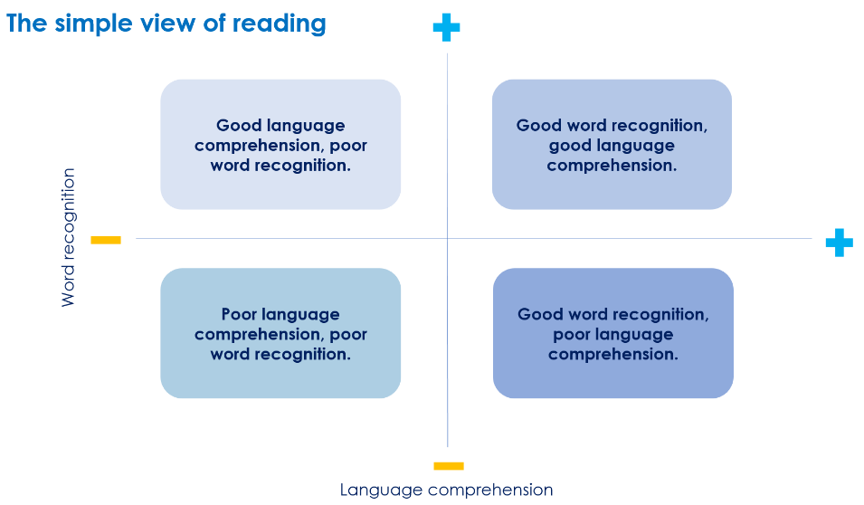
When focusing on how we teach reading it is worth reflecting on the Simple view of reading, which makes clear the importance of developing both children’s discrete word-reading skills and comprehension.
However, as expert reading teachers we look even deeper into the components used to become a mature, independent and fluent reader.
Scarborough’s Reading Rope (below) provides a useful model for reading by likening it to a rope comprised of multiple strands. The two main strands, word recognition and language comprehension, are supported by a broad academic consensus and underpinned by research evidence. These two main strands are composed of sub-strands that need to ‘become entwined’ as pupils learn to coordinate the different components of reading.
Although all of the strands represent an important component of reading this does not mean that they require equal curriculum time. For example, most pupils will require a greater focus on their language capability (language structures and vocabulary) and reading fluency, but some will still need a focus on more basic skills, such as decoding. Therefore, it is important to understand pupils’ current capabilities and focus effort appropriately.
Fluent readers can read quickly, accurately, and with appropriate stress and intonation. A fluent reading style supports comprehension because pupils’ limited cognitive resources are freed from focusing on word recognition and can be redirected towards comprehending the text. There are no quick ways to develop reading fluency and it is something that develops over the course of children’s education at North.

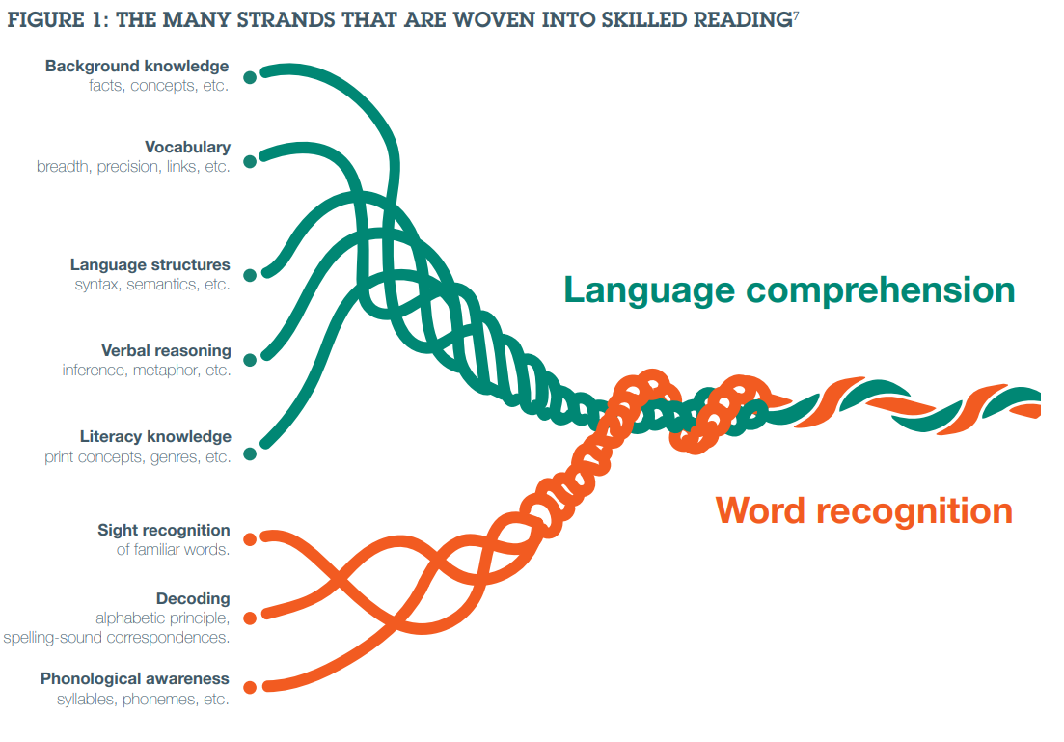

At North we also think of reading development as being a continuum, as put forward by the Centre for Literacy in Primary Education (CLPE).
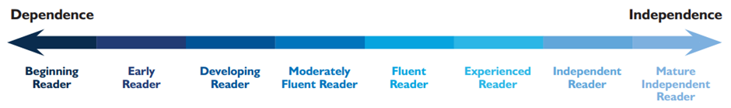
We aim to ensure children progress along this continuum toward becoming a mature independent reader when they leave at the end of key stage 2. The CLPE reading scale sets out the reading behaviours and next steps for each stage on the continuum. As leaders, teachers and parents we are constantly developing our use of and understanding of this continuum.
Teachers use this to differentiate and personalise learning as it enables us to develop a clear picture of where the child is and what they need to do to make progress. By using this alongside our assessment systems we are able to personalise learning, not just in order to meet assessment statements, but also to allow development of readers as a whole – including reading for pleasure. The reading continuum (accessed via link below) describes the stages in detail, as well as the next steps for each stage. https://docs.google.com/document/d/1csCaaZHHI66wxVYqZxHrK-WVaFlNX9ITCGLufqGKHxY/edit

How we teach reading
Phonics | Shared  reading | Reading skills | Class reading | Independent reading | HOTS reading tasks | Language acquisition | Knowledge of the world
Children blend and segment phonemes and graphemes in order to sound out words and then apply this to texts | Modelling and analysing texts as a group/class  Children working with challenging texts | Explicit teaching of comprehension skills thorough shared texts and comprehension texts  VIPERS | Children working in classes with text selected by teacher focusing on skills  VIPERS | Children working with self-selected material and phonically decodable books and Must Reads including familiar texts, that will be used in school and at home | Children working individually, in groups or as a whole class to use and apply their reading skills to complete a range of HOTS tasks related to reading | Building vocabulary across the curriculum. Learning subject specific and enriching vocabulary.  See separate vision | Teaching an effective wider curriculum to ensure children have a deeper and wider knowledge to apply to new learning
Reading for pleasure underpins all

Early Reading - Phonics
At North we use Read, Write Inc (RWI) to teach word recognition and learning to decode words fluently. Children blend and segment phonemes and graphemes in order to sound out words and then apply this to text. The use of a carefully sequenced systematic synthetic phonics programme enables us to support all chn to become readers. All staff delivering RWI are trained and the implementation and impact of the programme is overseen by our Reading Leader. The comprehensive programme implemented in speed sounds sessions alongside phonically decodable texts, carefully structured sessions including all elements of English learning mean children are learning and applying their growing phonics knowledge daily.
This takes the form of daily sessions taught in groups using texts focussed on embedding specific sounds using the revise, teach, practice and apply approach. As each new sound is taught, children continuously revise and practise previous sounds, and they learn to form the letters and blend these sounds in order to read words. As they become confident in identifying the individual sounds within words, they begin to segment words into sounds in order to write whole words, at first with support and then independently. The children are assessed at the end of every half term, and the groups are changed according to the needs of the children.
In year 2 some children are identified as needing some additional support in acquiring phonics and will continue to be explicitly taught phonics using the RWI programme. Across all year groups we understand that phonics can be taught and when utilised effectively as it has benefits for anyone in the dependent stages of the reading continuum. We also utilise phonics in our personalisation of teaching reading, for example to support a new student from a non-English speaking country. In KS2 we use Fresh Start in order to meet the needs of new arrivals and ensure they receive a curriculum that will allow them to quickly gain the foundation skills in order to access the full curriculum.
When children complete the programme and have developed their phonic knowledge and fluency in decoding, we then move them onto the language and literacy programme which continues to develop fluency in decoding and further develops children comprehension skills before transitioning on to the year 2 class reading curriculum.

Shared reading
All of our children enjoy regular opportunities to listen and respond to texts read out loud by an adult, modelling the use of expression and introducing them to new vocabulary, which they may find challenging if encountered independently. The importance of this activity is clearly indicated in the 2014 National Curriculum which stressed the importance of:
‘listening to, discussing and expressing views about a wide range of contemporary and classic poetry, stories and non-fiction at a level beyond that at which they can read independently.’
Learning to read is a complex process and one that places great demands on a child’s cognitive ability to draw on their prior learning and emotional willingness to take visible risks. The first and most important resources that young readers have are a strong foundation of spoken language. Children will also need to have experience of sharing reading for pleasure and purpose.
Shared reading (reading to or reading aloud) involves students listening to a text read aloud by the teacher (or in some instances a mature independent reader). The teacher is able to model skilled reading behaviour, enjoyment and interest in a range of different styles of writing and types of text. It provides an opportunity for teachers to demonstrate their enjoyment in reading, and allows students to see a purpose in learning to read.
Shared reading is an essential part of daily reading at North within the English lesson using our Power of Reading texts. In the English learning time we read to and with children as we know this develops students' understandings about reading while building a background of text experiences that they can draw on as they learn to read independently. It also enables teachers to model good reading behaviours while providing opportunities to familiarise students with the linguistic and visual features of text. As well as demonstrating fluent and expressive reading, teachers can also model the comprehension of unfamiliar or complex vocabulary; and talk through their thought processes when comprehending a text. Similarly, analysis of the composition of the pages, use of visuals, elements of the text structure, sentence structure and language impact can also be highlighted and discussed. This all occurs in an authentic literacy experience, where modelling of reading texts for pleasure can stimulate thinking and motivate students to read.

5 a day diet
In EYFS and KS1 we ensure children have a 5 stories a day diet. This exposes children to quality stories and ensures appropriate time is spent engaging with a story and experiencing what it is like to enjoy and become immersed in a book.
RWI | Class  reading | Story time | Black & white books | Book bag books & Must reads
Children are either read to and reading themselves daily within the RWI programme. | Children are read to and/or reading themselves in daily class reading sessions. | Teachers read stories to children during the school day. | Children have copies of the books they have read in RWI to read anytime at home. They are reminded to read their current text daily while it is being studied as part of the RWI programme. | Children have phonically decodable texts aligned to their point on the RWI programme (just below the stage at which they are in the programme in order to ensure children have success in reading independently).

Reading skills
Reading skills are taught, used and applied through shared reading, through immersion in quality texts in English lessons, whole class reading, modelled reading, focused Higher order thinking tasks and high expectations and recording of home reading (these will be laid out in our homework policy).

The skills taught in reading also permeate all other subject disciplines at North Primary School, and are used and applied across all areas of the curriculum. Through these activities, children experience a range of text types, have reading modelled to them and ask and answer a range of question types to enhance their understanding of the text. Within this questioning and discussion there will also be a focus on stylistic analysis where children deepen their understanding of how/why an author uses grammatical features, sentence construction, plot development, characterization, punctuation and vocabulary to enhance the readers' enjoyment and understanding of the texts studied. We also recognize that language acquisition/vocabulary building is integral for successful readers and again this permeates every area of our curriculum and every teacher-learner interaction, with specific focus taken within teaching and learning of reading skills.

We use the structure of VIPERS to explicitly teach our reading skills. This gives children and teachers a shared language for reading skills and allows teachers and pupils to ask and answer questions within consistent frameworks.
KS1 KS2
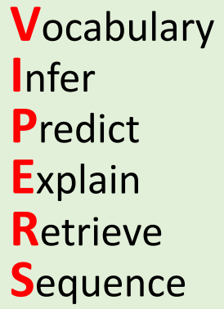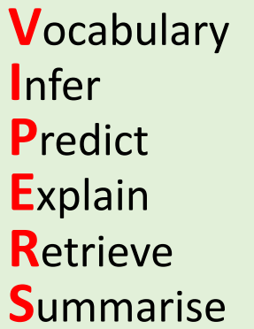
Teachers will also use strategies to support reading which are laid out in the North Primary reading strategy booklet. Follow the link below https://docs.google.com/document/d/1_H7UsfcEU_Bb7kKX5kJWA38wjv3YL64YlL3lFtTyRQU/edit

Class reading
Year 2
In year 2 children transition from the RWI programme into class reading. We recognise that children progress at differing rates in reading and moving along the continuum. Our structures for reading in year 2 enable children to move onto reading demanding texts whilst also supporting all children to become fluent readers.
Autumn term transition map
Autumn | Spring | Summer
Pink & orange - moving to yellow/blue | Yellow and below - stay with RWI  Blue/Grey - Assess fluency in decoding at the end of Autumn term and move to PoR lessons for Spring term. If fluency is still an issue look at further support to increase fluency (PiXL therapies and strategies). | PoR English curriculum - further support to build fluency for those who need support
Yellow group - moving to blue group | PoR English curriculum
Comprehension - language and literacy
Comprehension - (9 modules left then moving to PoR) language and literacy - need short sharp speed sounds recap lessons including alien words during autumn term
Year 2 class reading cycle
Monday | Tuesday | Wednesday | Thursday | Friday
PiXL input  Focus on a specific skill.  Have some independent questions for the end of the session based on a short extract. | Read a high quality text  Introduce the vocabulary.  Introduce the text (possibly make predictions).  Echo reading (with prosody) Talk about the book.  Adults to model Q&A of what would be expected to answer oral questions.  Draw on specific skill taught through PiXL yesterday. | Read a high quality text  Read text again.  Talk around the specific skill.  Questioning (use question stems from this Reading Vision document)  for synthesis and use sentence stems to support (may be quite oral in Autumn term, but more to more written questioning later). | VIPERS Task  Apply multiple VIPERS skills (use question stems from this Reading Vision document). | Guided comprehension  Not linked to topic, but taken from PiXL materials/high quality comprehension texts/ standardised assessments.  Modelled session.  Reading with children.  Agile teaching should be used  Metacognitive thinking to show skills (skimming & scanning, underlining key words in text, understanding the question word, etc).
Spring term - Move to more complex, longer texts.

Transition from KS1 to Ks2
As children transition some will still require support with decoding and some will require further support to decode fluently. As these are barriers to progress in reading and across the curriculum, children identified as needing more support in these areas will receive additional support and the curriculum will be adapted to ensure all children make good progress in reading. We adapt our grouping of children according to need and in response to data.

3:1:1 KS2 approach
Once children are in KS2 we follow a 3:1:1 approach to ensure children gain fluency in comprehension, apply VIPERS skills to various texts/stories including full novels and are prepared to excel in reading. There is flexibility within this approach in terms of which days each session takes place on and this is up to teachers to sequence.

Monday | Tuesday | Wednesday | Thursday | Friday
VIPERS read and respond based on PoR text | HOTS task based on PoR text | VIPERS read and respond based on PoR text | Guided comprehension | VIPERS read and respond based on PoR text
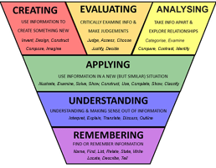
VIPERS: Teachers prepare questions for pupils. This is based on formative and summative assessment and the need for children to have a deep understanding of the challenging stories they are reading. Teachers will adapt through use of sentence stems to support lower attainers and agile teaching to move children on to more challenging questions. Children will be expected to read sections of text independently at certain times to support fluency and monitoring of comprehension.
HOTS: Children carry out tasks that require them to create, analyse and evaluate. This allows children to apply their knowledge of a text in an original and creative way. These will include challenge and scaffolds to ensure all learners are able to apply their thinking.
Guided comprehension: teachers use metacognitive modelling to walk and talk through a comprehension. They model strategies to children that enable them to apply skills and answer questions. Teachers use agile teaching to move children on to independent work, while utilising AfL to focus on this who need more support and scaffold.

Independent reading
With the reported decrease in the time children spend reading at home it is vital we promote and embed reading independently as part of our school ethos. Reading at school for a sustained period is important if children are to develop as self-reliant readers, able to select a book and sustain their concentration. We aim to teach every child to read well, making time within the school day to read, and embedding a culture of reading into the core of what we do. Providing time for independent reading is equitable because it means that every child, including those who do not read at home, has time to enjoy a book.
We build time for independent reading into the school day. Every day from 8.40-8.50 children will read self-selected texts. This calm and purposeful start to the day puts independent reading and reading for pleasure at the forefront of the curriculum.
All children have access to our library which is under an ongoing refurbishment including making the are more aesthetically pleasing. As well as this we ensure high quality texts that children want to read and represent the diversity of our community are available.
Every call also has a library of ‘Must-Reads’ which are carefully selected texts that every child in the year group is expected to read (with adult support for some less fluent/younger readers). These are loaned out throughout the year in addition to the library books.
Children undertaking the RWI scheme have phonically decodable texts matched to their growing phonic knowledge. Books they have read as part of the programme in school are sent home to keep. This means by the end of the programme children can have a home library of 100+ familiar texts. In addition children are able to borrow books in line with their growing phonic knowledge . We call these book bag books. These are monitored by the children’s RWI group teacher.
Must reads + library

Language acquisition
We strive for all of our learners to have a rich and varied vocabulary, particularly as research has shown a direct correlation between wide vocabulary and greater academic and financial success later in life. We know that pupils who enter school with limited speaking and listening vocabulary -high performing five year olds - will have an oral vocabulary of about 14,000 words which is almost twice as much as low performing pupils and that gap gets wider each year. We aim to narrow this gap significantly while at North Primary.
Our approach to teaching and learning of vocabulary is laid out in our vocabulary vision. Please follow the link below
https://docs.google.com/document/d/1N_IYCTZ4Xh0joc_-oK9PMxmMiRdYMwDsVORJUEHBNdA/edit

Knowledge of the world
Through effective teaching of the wider curriculum we build knowledge of the world. We read and apply our decoding and comprehension skills to all areas of the curriculum. We must remember - all learning requires reading (or a skill learnt through reading) in some form, and all learning supports development of reading skills as it builds knowledge of the world, upon which all inferential skills are dependent. In addition, we ensure children

How we assess reading
As part of our focused work on reading, when children are reading, either individually or as a group, we assess horizontally and vertically using formative assessment statements alongside the stages of the reading continuum. For summative assessment we utilise PiXL assessments termly.
The evidence for our formative assessment (AfL) is based upon question and answer, book talk, HOTS tasks, English writing using text as stimuli, reading record evidence, comprehension work and individual responses to texts in reading (essentially any reading based interaction with the learner!). In addition the teacher hears every child in their class read once a half term and this is updated on a running record. Teachers carry this out during visits to the library.
Alongside this we also use termly summative comprehension assessments to inform us of learners’ progress and attainment as well as any knowledge and skills gaps. Using this we are able to give feedback and incorporate personalised targets and focus areas into our planning –teaching-assessing cycle. When addressing gaps in reading we prioritise children having the foundation knowledge and skills to allow them to access the curriculum.

Assessment skills
At North we recognize that achievement can be measured by summative attainment. Therefore we aim to ensure all of our children are prepared for assessments. In the week before the whole school assessment week each term, we teach children through guided ‘walking and talking’ comprehension assessments, explicitly teaching the expectations, techniques and skills to effectively navigate and achieve in these assessments. Below is a sample timetable for the morning reading session this week.

A ‘Power of Reading’ school
The 2014 National Curriculum states:
‘Pupils should have extensive experience of listening to, sharing and discussing a wide range of high-quality books with the teacher, other adults and each other to engender a love of reading at the same time as they are reading independently
‘Reading and listening to whole books, not simply extracts, helps pupils to increase their vocabulary and grammatical knowledge, including their knowledge of the vocabulary and grammar of Standard English. These activities also help them to understand how different types of writing, including narratives, are structured. All these can be drawn on for their writing.’
In 2016, North became a ‘Power of Reading’ school. The ‘Power of Reading’ is a programme which puts high-quality texts and creative teaching approaches at the heart of all planning, teaching and learning of English. Initially established by the charity CLPE (the Centre for Literacy in Primary Education), the ‘Power of Reading’ aims to nurture a love of reading and writing in children by immersing them for several weeks in texts that have strong emotional or moral themes children will connect with. An extensive range of text-types are encountered during the reading of each book, and the children’s writing is enhanced by participation in speaking and listening activities, book discussion, drama and art. Additionally, the gradual construction of a working wall and a collection of text level work, enable children to track their progression and learning through the time spent on the text. This immersion has a hugely positive impact on children’s motivation in reading and writing, as well as their confidence in discussing what they have read.
Through careful consideration and discussion, as well as consultation with CLPE and other ‘Power of Reading’ schools, North has carefully selected texts for our Power of Reading curriculum, which aims to present children to a wide range of authors and themes as they progress vertically through the school. These texts are laid out in our ‘Out of this world’ curriculum documents.
Teachers at North plan learning opportunities for children based on these texts, whilst providing them with opportunities to embed and practise grammar, punctuation and spelling rules, learn and use rich and varied vocabulary, and use an editing and improving approach to writing.

A reading community
All staff members recognise that we are a community of readers. Staff share their favourite books, recommended reading and current reading through displays in the classroom and shared areas. We encourage volunteers and regular visitors to the school to do the same.
We also have a lending library for staff located in our staffroom. Staff are encouraged to bring and borrow books (including children’s fiction) and discuss and recommend books to one another.

Spoken Language
The national curriculum for English states:
‘Spoken language underpins the development of reading and writing. The quality and variety of language that pupils hear and speak are vital for developing their vocabulary and grammar and their understanding for reading and writing. Pupils should develop a capacity to explain their understanding of books and other reading, and to prepare their ideas before they write. Pupils should also be taught to understand and use the conventions for discussion and debate. All pupils should be enabled to participate in and gain knowledge, skills and understanding associated with the artistic practice of drama.’

It also maintains that children must learn to:
‘participate in discussion about what is read to them, taking turns and listening to what others say’.

At North, pupils encounter a range of experiences designed to support them in becoming clear and audible orators, who are confident speaking for a wide range of purposes. These include:
- describing incidents from their own experience
- telling a well-known story
- creating dramatic roles and experiences through devising scenes
- performing from scripts
- explaining processes verbally, using subject-specific vocabulary
- explaining and justifying their own opinions and choices
- elaborating on knowledge and understanding
- responding to others appropriately, using correct, standard English
- keenly engaging in discussion about texts they have read and enjoyed
- listening and responding to stories, songs, rhymes, poems, and visual media
- debating issues with their peers
- rehearsing and performing presentations

Parental Engagement
We use a simple chart format within our Reading Journal for recording whether a child has read at home, either independently or with an adult. This can be motivating for children and allows a teacher to keep an overview of reading. We expect parents to simply date and initial to indicate what the child has read or optionally give further details in the comments section. Teachers will then check this fortnightly and date it. This reading record then ensures we have the basis for a genuine dialogue about reading.
In our dialogue with parents (which may take the form of brief face-to-face meetings or telephone conversations as well as Parent Evenings meetings) we aim to give parents clear targets (targets can help to focus the enthusiasm of many parents) for the next steps children need to make to develop their reading. This might be specific grapheme-phoneme correspondences in Year 1 or reading for a purpose in Year 5. We also ask parents for their views and by focusing on asking and listening rather than telling, we reinforce the partnership between home and school.
Throughout the academic year we have numerous workshops for parents (from informal non-academic, to support groups, to focused subject specific support), many of which focus on English and reading. In these sessions we take on board parental views and also work to ensure that the school and parents work collaboratively to promote reading both in school and at home.
We aim to reach every family; ultimately, however, it may not be possible to reach every family. Therefore we see reading at home as an extra. We do everything we can to ensure it happens, but accept that it may not. We aim to ensure equality in reading, making sure every child can read and has the opportunity to read for pleasure every day.

