Behaviour Report Card
Name: Class:
Teacher, please select a word to describe the child’s behaviour/mood during each session

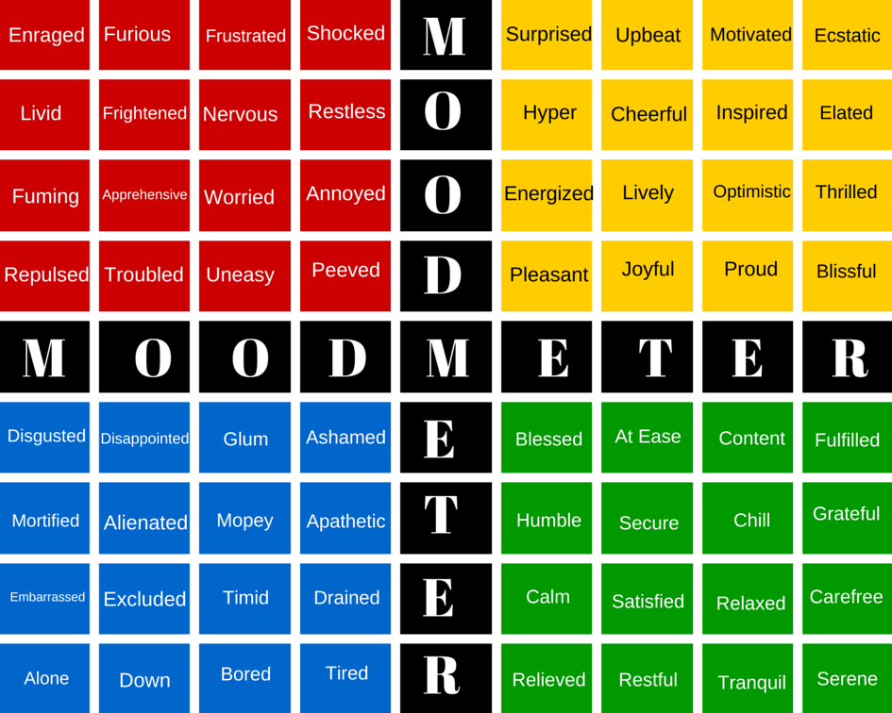

Week 1 | Monday | Tuesday | Wednesday | Thursday | Friday
9-10.30
Playtime
10.45-12.15
Lunch
1.15-2.15
2.15-3.15

Week 2 | Monday | Tuesday | Wednesday | Thursday | Friday
9-10.30
Playtime
10.45-12.15
Lunch
1.15-2.15
2.15-3.15

More information relating to the RULER approach: https://www.rulerapproach.org/

